51

Template for Field Trip Planning and Communication
With School Staff Members
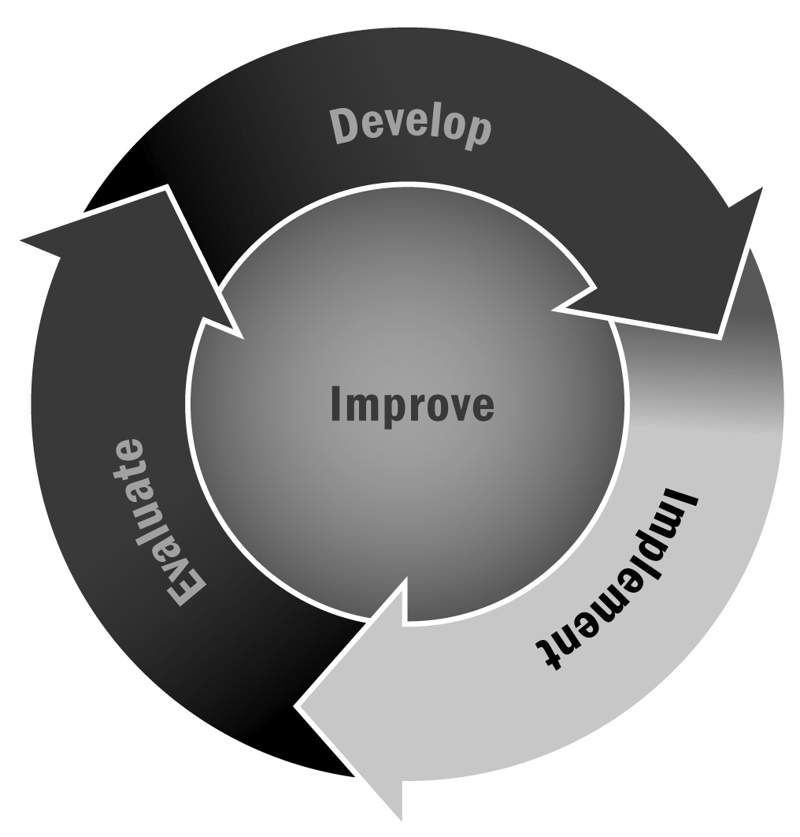
In Chapter 3, you learned about the importance of aligning your curriculum and activities with the information being covered during the school day. Allowing participants to build on school day learning through hands-on learning can reinforce school day lessons in a different way and provide a real-world application for participants.
Directions: Use the template on the following page when planning field trips and coordinating with teachers and staff members in your local school.

Tips for Written Communication
- Adapt and adjust all communication for your specific program and the person with whom you are communicating. Personalize whenever possible—refer to how you know the person, ask about something in his or her life, or simply wish the person well!
- Alter the format of your communication to fit the method you are using to communicate.
- If you are sending an email, for example, make sure your subject line clearly identifies the purpose of your email. An email that says “ABC Afterschool Program: Update on Field Trip Plans” is much more informative and likely to get the attention of your recipient than “Field Trip.”
- Make sure your contact information is always included in your email signature.
- If you are sending a letter or memo, be sure to include the date, and always sign your name at the bottom.
- If you are communicating via letter or a printed memo, use your program’s letterhead. If you do not have letterhead, use brightly colored paper.
- Remember to proofread and to follow up your letter, memo, email, or other written communication with a personal phone call. Taking a little extra time can go a long way.

Dear Teacher,

Our afterschool and expanded learning program is planning field trips for the next few months. Currently, we have the following trips planned:
[List trips here.]
We know that field trips are a wonderful way to expand the learning that goes on in our program and in your classroom. We would like to plan an afterschool field trip that supports a part of your curriculum. For example:
- If you are studying a particular play, we could go to a performance.
- If your class is studying Egypt, we could arrange a visit to an antiquities museum.
- If your class is studying plants and photosynthesis, we could take a trip to an arboretum.
[Provide another example if appropriate.]
If you would like to discuss ways in which afterschool field trips might support the teaching you are doing, please contact:
[Provide complete contact information here.]

Sincerely,

[Your/program name]
P.S. We are also happy to work with you to create enrichment guides for the field trips. Please let us know if you would be interested.

